|  | **Online Bakery**  **Technical Design Document** |
| --- | --- |
| |  | **Prepared By / Last Updated By** | **Reviewed By** | **Approved By** | | --- | --- | --- | --- | | **Name** | Md. Mehmood Alam  Debanjan Dhar  Srinjoy Gupta  Priyanjali Das  Shafaque Bushra |  |  | | **Role** |  |  |  | | **Signature** |  |  |  | | **Date** |  |  |  | |
|  |

**Table of Contents**

**1.0** **Introduction 3**

**1.1** **Purpose of this document 3**

**1.2** **Project overview 3**

**2.0** **Solution Summary 3**

**2.1** **Scope 3**

**2.2** **Assumptions 4**

**2.3** **Dependencies 4**

**3.0** **Schematic Diagram 4**

**4.0** **System Design 6**

**4.1** **Proposed design 6**

**4.2** **Component inventory 6**

**Model classes 6**

**5.0** **Database Design 7**

**5.1** **Data Model 7**

**5.2** **Table Structure 7**

**6.0** **Appendices 9**

**6.1** **Glossary 9**

**6.2** **Other 9**

**7.0** **Terms & Conditions 9**

**8.0** **Change Log 9**

# Introduction

## Purpose of this document

The purpose of this document is to document the technical design, component details and Database design. This will also capture the scope, assumptions, risk, dependencies of this project.

## Project overview

# An online Bakery shop that allows users to check for various bakery products available at the online store and purchase online. The project consists of a list of bakery products displayed in various categories. The user may browse through these items as per categories. The goal of this project is to create a dedicated and reliable platform for foodie.

# Solution Summary

## Scope

Online Bakery shop have the ability to provide varieties of bakery products .The users can register and order their favorite products to cart.The users can also search for the products by product name or product category.

1. User Registration: Users can register on the system and get their online account on site.
2. User Login: Users can login to the system and check various bakery items.
3. Product Categories: The bakery products are arranged and can be viewed in categories.
4. Product search : The customer can search for specific products.
5. Add to cart: Users can add new items to cart and proceed to checkout.
6. Dummy Credit Card Payment: After the total bill is calculated users can pay via credit card online.

## Assumptions

This application is designed for an end user and a business. A new user can register themselves in the system by providing their name, email, contact number and setting a password. They can subsequently login to the application using their username (email address) and password and view the various bakery items. Users can select the bakery items to purchase and add them to the cart and proceed to checkout by providing their address. Upon placing an order, the user receives a confirmation email to confirm their purchase. Users can provide feedback directly to the bakery as well as leave reviews to the products.

## Dependencies

* MySQL Workbench is needed for the database operations.
* Eclipse IDE used to build and run the application

# Schematic Diagram

A schematic, or schematic diagram, is a representation of the elements of a [system](https://en.wikipedia.org/wiki/System) using abstract graphics [symbols](https://en.wikipedia.org/wiki/Symbol) rather than realistic pictures. It gives an overview of the overall system

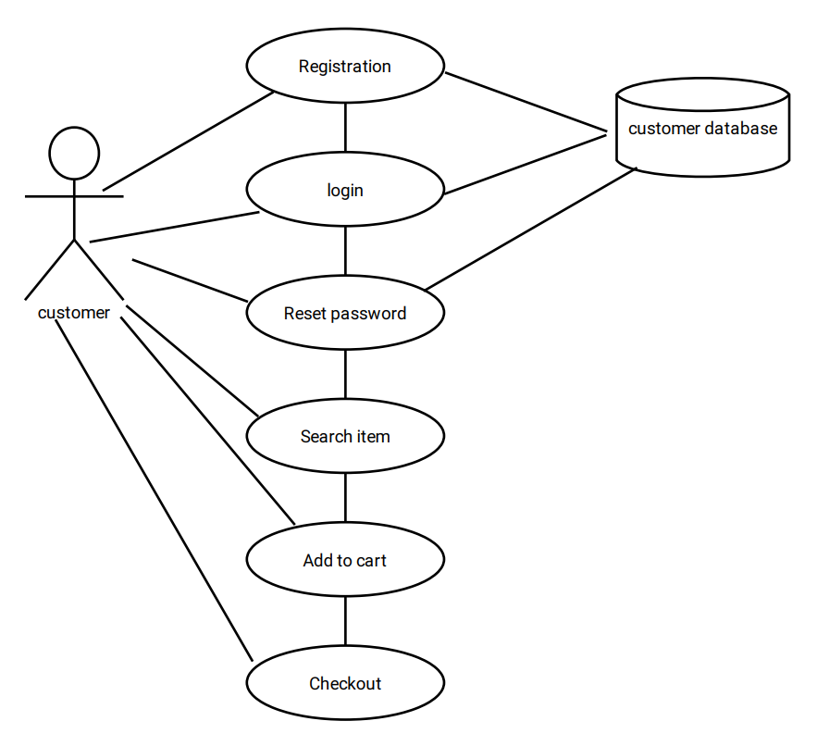

Fig: 3.1 Schematic Diagram

# System Design

## Proposed Design

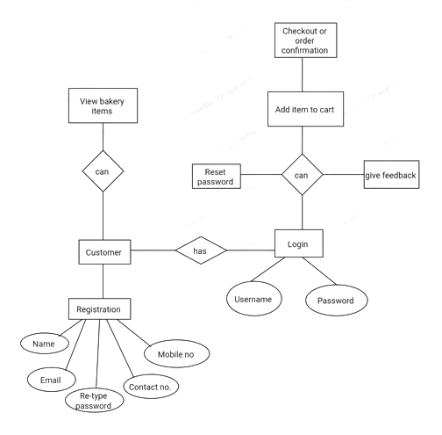

Fig 4.1: Proposed Design

## Component inventory

## Model classes

1. Registration.java
2. Login.java
3. Logout.java
4. ForgotPassword.java
5. ValidateOTP.java
6. NewPassword.java

# Database Design

## Data Model

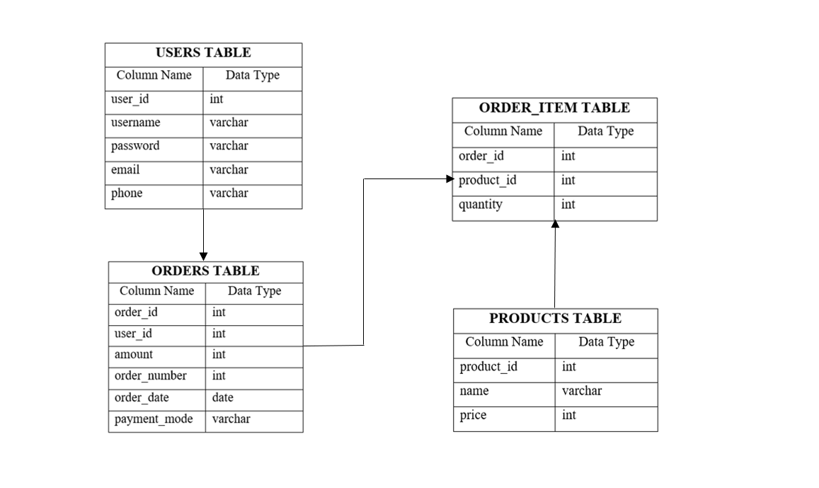

Fig 5.1: Data Model

## Table Structure

Users

| **Field Name** | **Field Type** | **Data Type** | **Mandatory** | **Possible Values** |
| --- | --- | --- | --- | --- |
| **user_id** | Text | Int | Yes | Pre-loaded |
| **username** | Text | varchar | Yes |  |
| **password** | Text | varchar | Yes |  |
| **email** | Text | varchar | Yes |  |
| **phone** | Text | varchar | Yes |  |

Orders

| **Field Name** | **Field Type** | **Data Type** | **Mandatory** | **Possible Values** |
| --- | --- | --- | --- | --- |
| **order_id** | Text | Int | Yes | Pre-loaded |
| **user_id** | Text | varchar | Yes |  |
| **amount** | Numeric | Numeric | Yes |  |
| **order_number** | Text | int | Yes |  |
| **order_date** | Date | date | Yes |  |
| **payment_mode** | Text | varchar | Yes |  |

Products

| **Field Name** | **Field Type** | **Data Type** | **Mandatory** | **Possible Values** |
| --- | --- | --- | --- | --- |
| **product_id** | Text | Int | Yes | Pre-loaded |
| **name** | Text | Varchar | Yes |  |
| **price** | Numeric | Int | Yes |  |

Order_Item

| **Field Name** | **Field Type** | **Data Type** | **Mandator** | **Possible Values** |
| --- | --- | --- | --- | --- |
| **order_id** | Text | Int | Yes |  |
| **product_id** | Text | Int | Yes | Pre-loaded |
| **quantity** | Numeric | Numeric | Yes |  |

# Appendices

## Glossary

| **Acronyms** | **Definitions** |
| --- | --- |
| 1.Admin | A person who owns the right to manage the upload and removal of products and is able to check users profile and their recent transactions. |
| 2.User | A person who can purchase products from the website and can give feedback about the product. |
| 3.Database | Necessary back-end . |
| 4.Add to cart | Selected products. |
| 5.Product search | The user can search for the specific products. |

## Other

# Terms & Conditions

***Disclaimer: Please do not circulate or distribute this document outside of Cognizant Network, we have a Zero Tolerance Policy. Kindly always adhere to 100% Compliance.***

# Change Log

*Please note that this table needs to be maintained even if a Configuration Management tool is used.*

| **Version Number** | **Changes made** | | | |
| --- | --- | --- | --- | --- |
| V<n.n> | *<If the change details are not explicitly documented in the table below, reference should be provided here>* | | | |
| Page no | Changed by | Effective date | Changes effected |
|  |  |  |  |
|  |  |  |  |
|  |  |  |  |
|  |  |  |  |